Meeting Date: | 13th May 2022
Subject: | Camp Place
Report from: | Marilyn Moore

Camp Place Play Park
Work is now complete on the main installation of Camp Place play park except for some remedial action on the groundwork and matting. It is anticipated that this will be completed very shortly. The local children have been enjoying the new equipment and footfall to the park has increased significantly. So far, all the equipment has been received enthusiastically and we look forward to it bringing many years of happy play to the local community.
The final invoices will be arriving shortly as the funding awards are being paid out. Then all the completion reports need to be written for the grants awarded, with relevant photographs included.
We are hoping to celebrate the official opening of the play park on Sunday 19th June between 11.00 and 15.00 hours. To keep it simple and in line with its use as primarily a local facility, it is intended that it will be a low-key family-friendly event with everyone bringing a picnic and a picnic blanket and wherever possible walking to the event to minimise any parking issues. The picnic tables have still to be installed.
Please note there will be no food vans on the site for the event.
Drummond Estates have kindly allowed us to use the field next to Camp Place Play Park for parking (Entrance in Geisher Road) and Mike Buchanan has offered to organise a grass cut of the field just before the event, for which we are very grateful. There will be some extra events over and above the play park equipment with fun competitions, face painting, orienteering, Splat the Rat, a home baking stall and toy and book swap/sell. Rugby, football and cricket coaches will be there to give some skills training, and there will be some gym challenges, so let’s hope for a fine sunny day. Various local organisations are helping with the event, for which CCC gives our grateful thanks.
Some photos of the finished play park presented below.
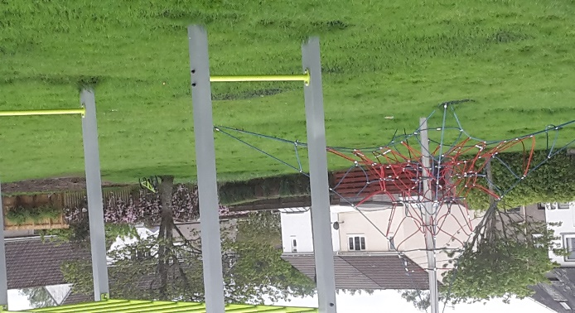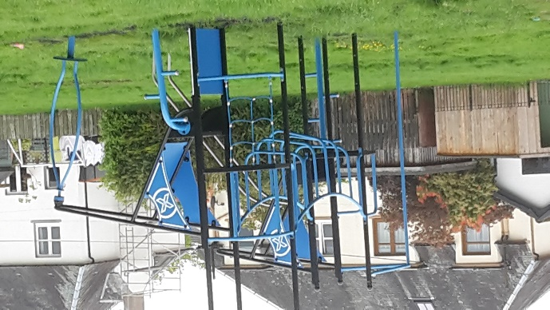
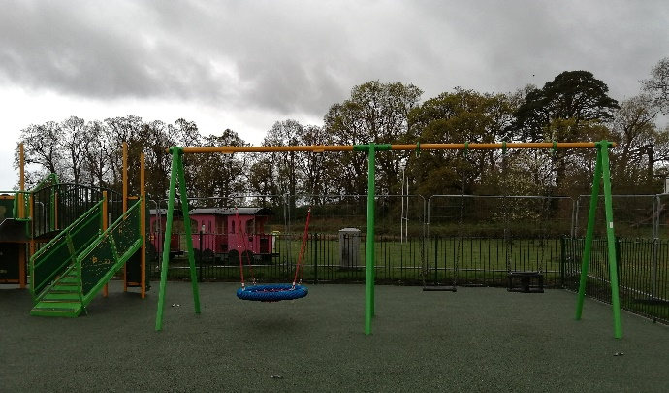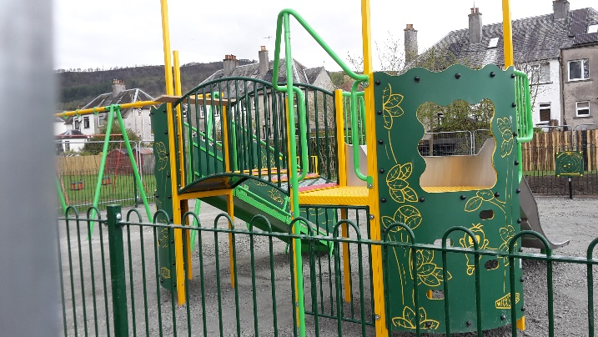
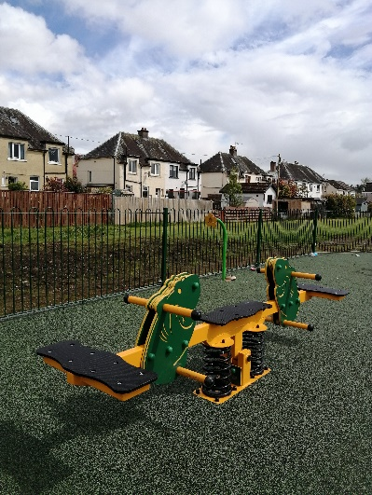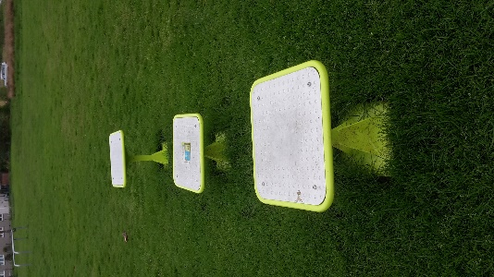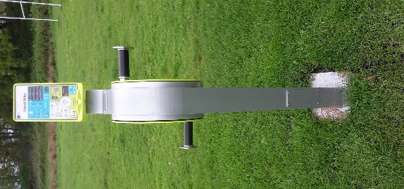

BMX/Bike Track
Following a good meeting with the team, we have some other ideas as to how to manage the insurance and restart the project. Once the play park is finished!
Marilyn Moore
Callander Community Council

